7.5.4 Rotation of Axes; Second Degree Equations

So far, all major/minor axes, transverse/conjugate axes, and directrixes have been vertical or horizontal. We now consider situations where this is not the case.

Example 1:
Consider (it is a hyperbola). Rotating the x and y axes by makes it easier to analyze this hyperbola.
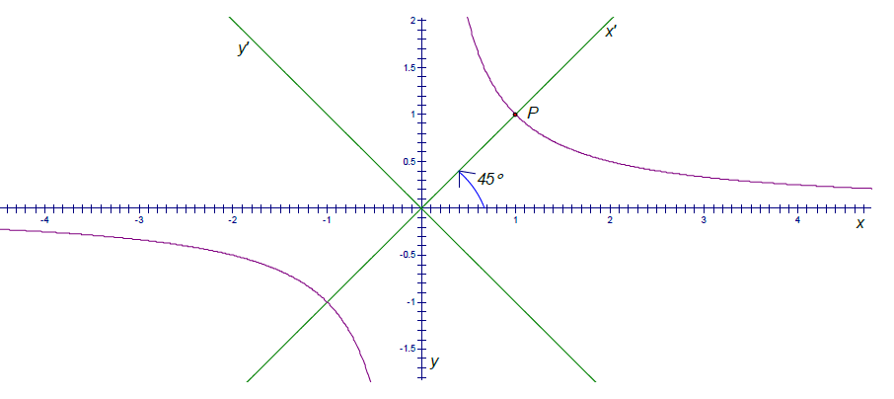
In the picture the hyperbola is in purple, and the new x and y axes (after the rotation) are in green.
This hyperbola appears to have been tilted.

Note: P has coordinates with respect to the xy-plane and with respect to the -plane. Can you figure out P’s coordinates with respect to each plane?

Coordinates of P with respect to the xy-plane:
Coordinates of P with respect to the -plane:

Note: The key to figuring out P’s coordinates with respect to the -plane is recognizing its distance from the origin. We will generalize this idea in the next example.

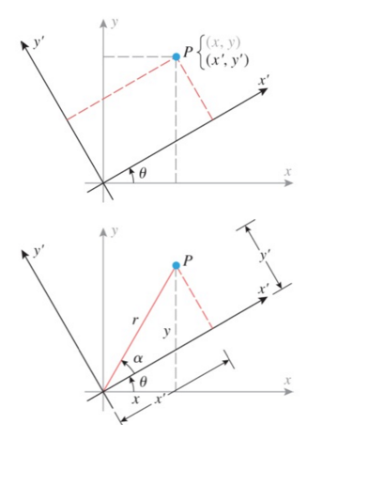
General Idea:

If a point P has xy-coordinates of then after rotating the axes by we can find the -coordinates by using the following equations:

Using identities for we can see that:

Then by substituting in the in the equations for we have:

We can also develop equations for as follows:

Multiply the first equation by and the second by :

Similarly if we multiply the first equation by and the second by :

Theorem: Let be the angle of rotation of the x and y axes. If is a point in the original system and is the same point in the new system, then

Note: We can see that this theorem does indeed work if we consider example 1.

Example 2:
Find the new coordinates of the point if the new coordinates axes are rotated through an angle of .

Using the equations above we have:

Therefore the coordinates of the new point are

Example 3:
Express in terms of new -coordinates by rotating the axes through an angle of

Using the equations above we can replace x and y and obtain:

Theorem: If a conic is given by the equation
is such that , and if an -coordinate system is obtained by rotating the xy-axes through an angle satisfying

then, in -coordinates, the given conic will have the form

Proof: see textbook pages 750&751.

Note: We will always choose to be acute.

Example 4: Identify and sketch the conic given by the equation

Since the equation contains an xy-term we know that it is a rotated conic.
We begin by attempting to find the angle of rotation using the previous theorem.

In order to convert the equation we need to find the value of x and y using the first theorem from this lesson.

We can use these equations to convert the given equation:

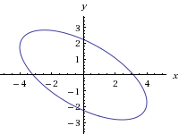
This is an ellipse with a center of . Note that , so the coordinates of the foci (with respect to the new axes) are .

Example 5: Consider the conic given by the equation

Find equations for x and y needed to express this conic with respect to the axes.

We begin by attempting to find the angle of rotation using the previous theorem.

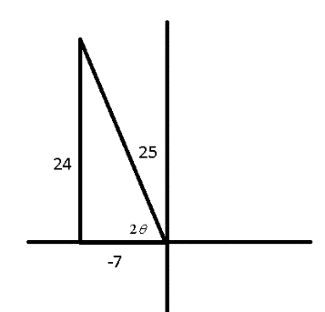
Since this equation is not easy to solve for we will instead use a triangle and some trig. identities:

Notice that now we do not need to find the value of and can begin to find the value of x and y:

From here we could continue and rewrite the given equation with respect to the -axes.
Example 6: Show that the given equation is a parabola, then find its vertex, focus, and directrix in terms of the xy-axes and sketch a graph.

Since the equation contains an xy-term we know that it is a rotated conic.
We begin by attempting to find the angle of rotation using the previous theorem.

Since this equation is not easy to solve for we will instead use a triangle and some trig. identities:

We can use these equations to convert the given equation
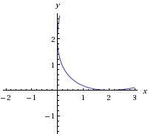

This is a parabola with .
Therefore it has vertex , focus, and directrix with respect to the -axes.

To convert these to points/lines in the xy axes we will use the equations from the first theorem:

Vertex: Focus:

Directrix: We have , so

